**SRFC TV / LOI TV Graphics List Shamrock Rovers v Dundalk Friday 2 July 2021**

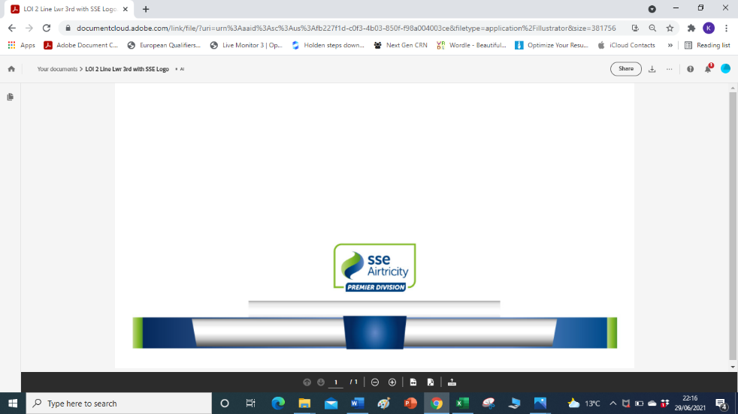

**LOI 2 Line Lwr with SSE Logo**

**Team Crests**

Tallaght Stadium Kick-off 8pm

Shamrock Rovers v Dundalk

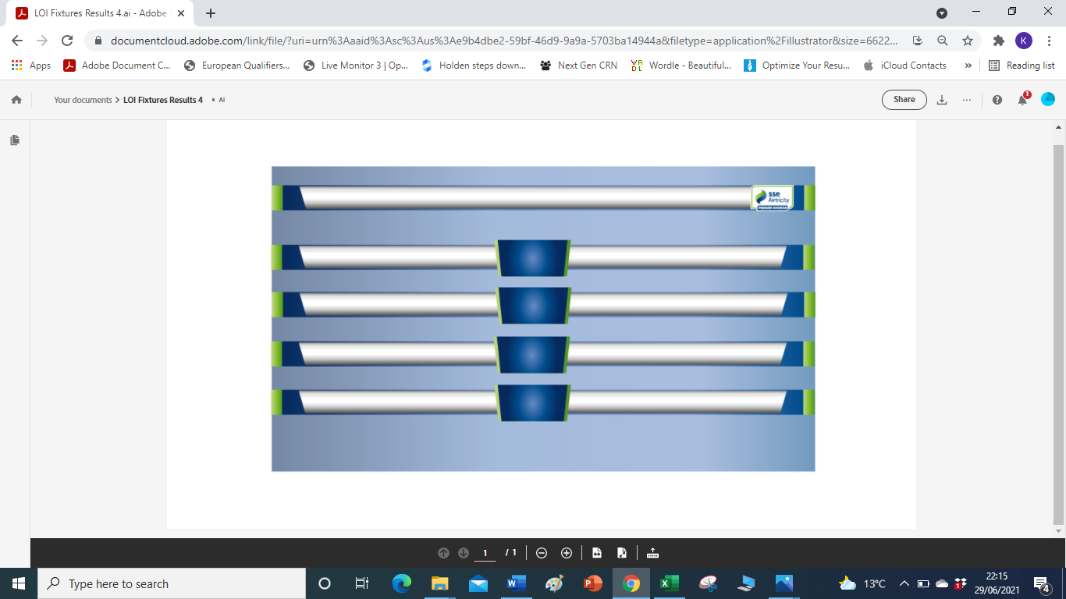

**LOI FIXTURES RESULTS 4 (**4 games)

**LOI FIXTURES RESULTS 5** (5 games)

Tonight’s Games / Tonight’s Results

Bohemian FC v St. Patrick’s Ath

Derry City v Waterford FC

Drogheda United v Finn Harps

Shamrock Rovers v Dundalk

**No crests required**

**LOI Team Sheet Home 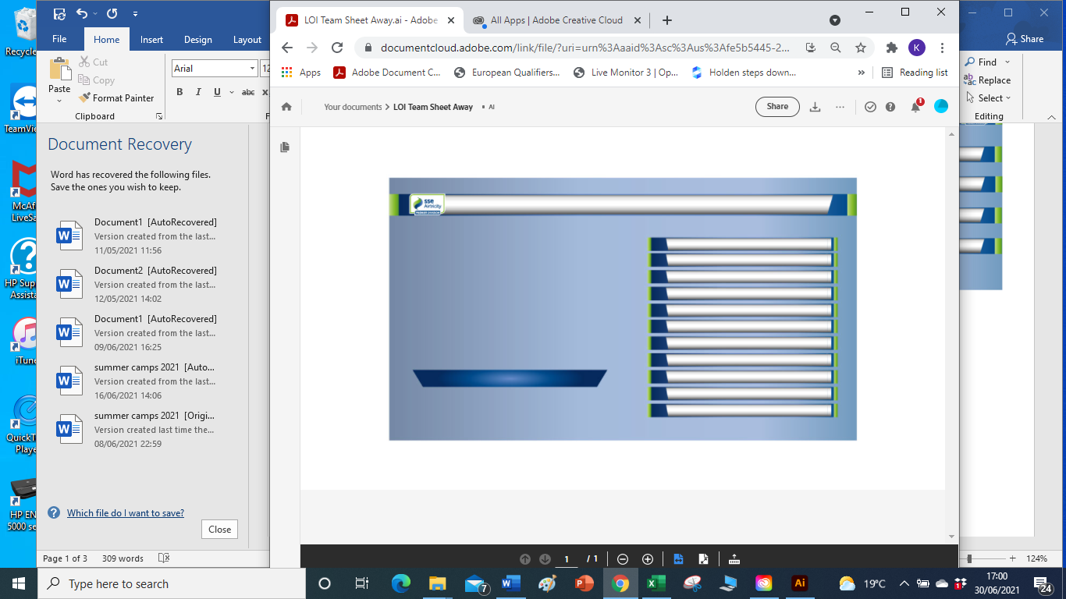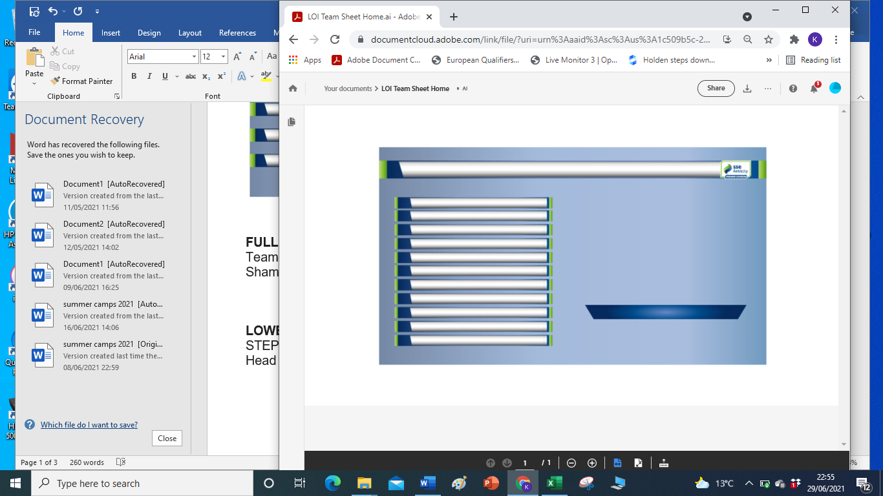 LOI Team Sheet Away**

Team Name Aligned Centre Team Name Aligned Centre

Shamrock Rovers (Aligned Left) Away Team, (Aligned right)

Head Coach / Manager in blue chevron

**LOI Team Sheet Subs Page**

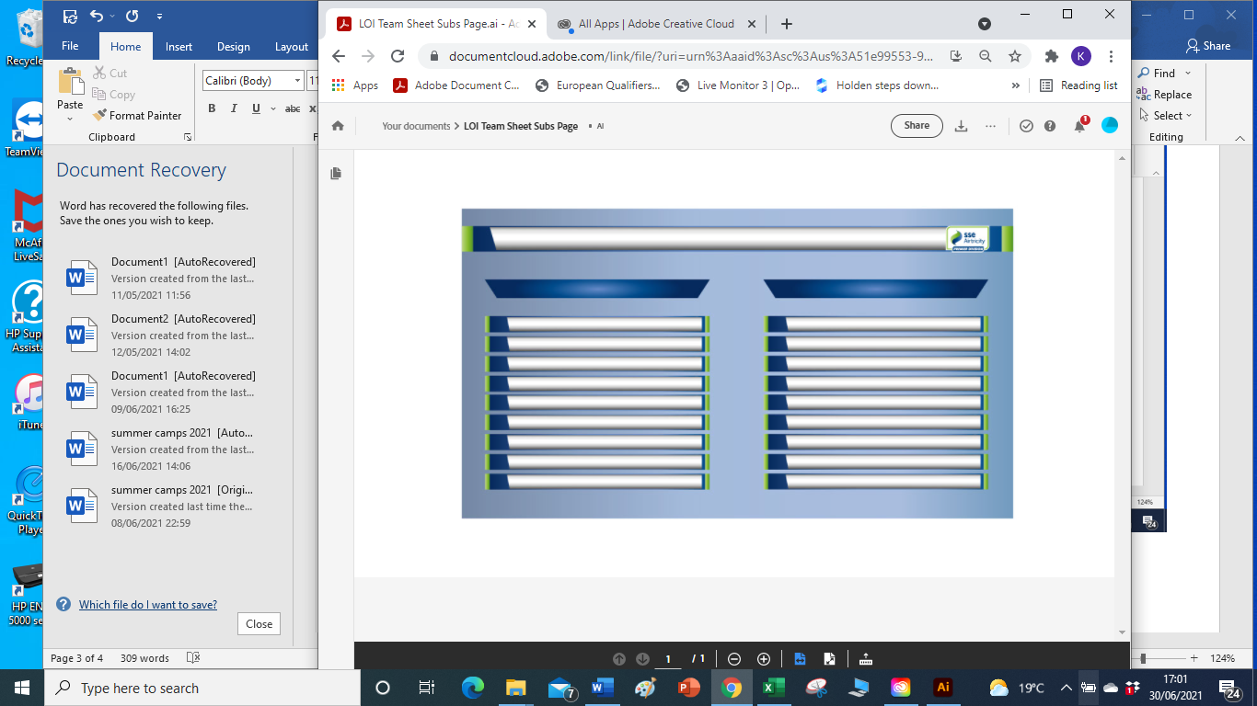

Substitutes

Team Names in Blue Chevron

8 Conor REEVES

Player Names Firstname SURNAME

Head Coach: Stephen BRADLEY

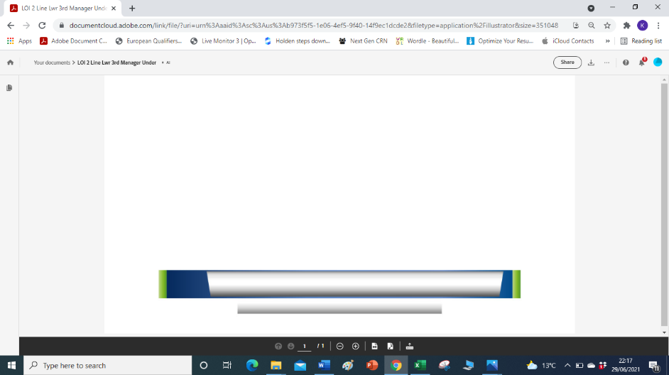

**LOI 2 Line Lwr 3rd Manager Under**

For Pre & Post Match Interviews

Stephen Bradley

Head Coach

*Centre Aligned*

*Insert Crest in blue area on left side.*

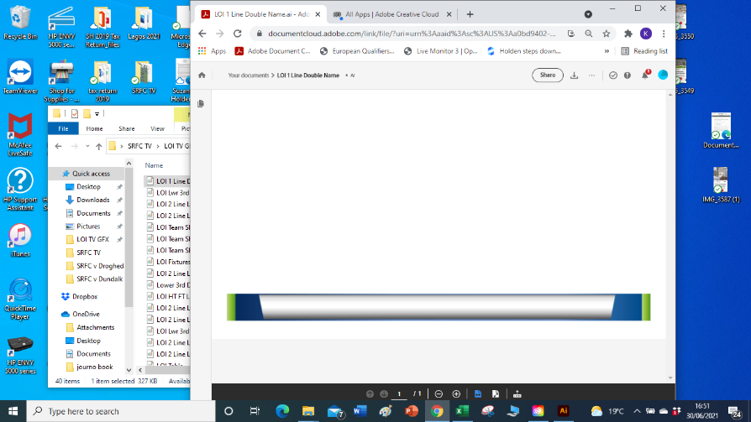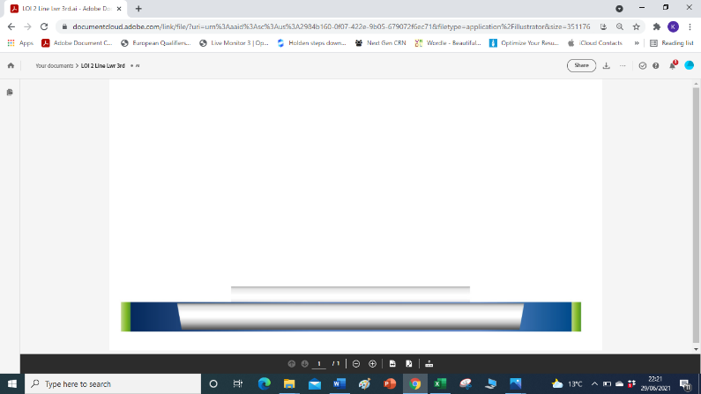

**LOI 2 Line Lwr 3rd** Commentators

Con Murphy & Xxxxxxxx

**LOI 1 Line Double Name** Xxxxxxx & Con Murphy

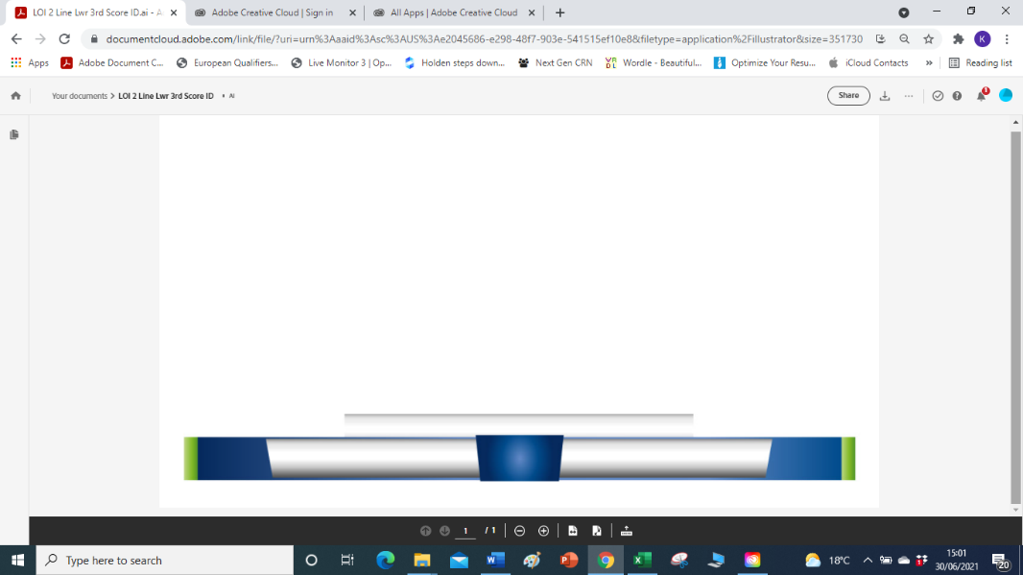**LOI 2 Line Lwr 3rd Score ID**

Tallaght Stadium   
Shamrock Rovers v Dundalk

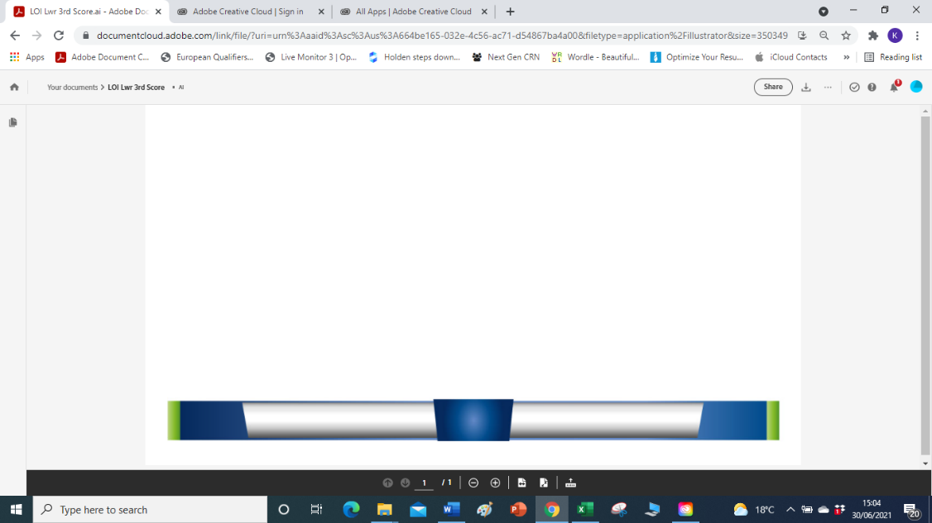

**LOI Lwr 3rd Score**

*Insert Crests*

Shamrock Rovers 0-0 Dundalk

Shamrock Rovers 1-0 Dundalk

Shamrock Rovers 2-0 Dundalk   
Shamrock Rovers 3-0 Dundalk

Shamrock Rovers 0-1 Dundalk   
Shamrock Rovers 1-1 Dundalk   
Shamrock Rovers 2-1 Dundalk

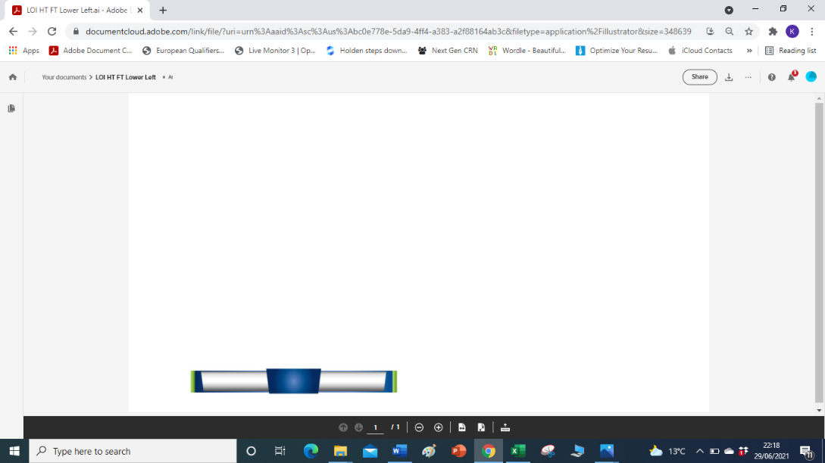**LOI HT FT Lower Left**

*Enter HT or FT*

HT SHA 1-0 DUN HT SHA 2-0 DUN   
HT SHA 3-0 DUN HT SHA 0-0 DUN

HT SHA 1-1 DUN HT SHA 2-1 DUN

HT SHA 0-1 DUN

FT SHA 1-0 DUN FT SHA 2-0 DUN   
FT SHA 3-0 DUN FT SHA 0-0 DUN

FT SHA 1-1 DUN FT SHA 2-1 DUN

FT SHA 0-1 DUN

**No crests**

**LOI FIXTURES RESULTS 4 (**4 games)

**LOI FIXTURES RESULTS 5** (5 games)

Tonight’s Results

Bohemian FC X-X St. Patrick’s Ath

Derry City X-X Waterford FC

Drogheda United X-X Finn Harps

Shamrock Rovers X-X Dundalk

**No crests required**

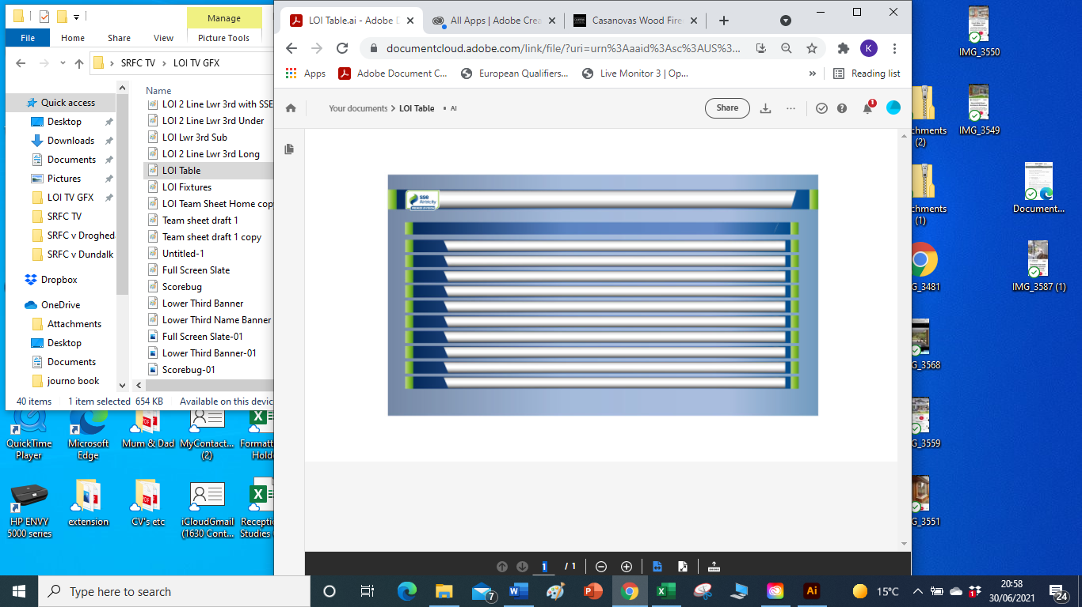

**LOI Table**

SSE AIRTRICITY PREMIER DIVISION

PLD GD PTS

1 19

2 19

3 18

4 19

5 19

6 19

7 19

8 19

9 Waterford FC 19 -24 13

10 Longford Town 18 -19 9

TICKER

SHAMROCK ROVERS: &nbsp 1 MANNUS &nbsp 2 GANNON &nbsp 15 SCALES &nbsp 5 GRACE &nbsp 3 HOARE &nbsp 24 MURPHY &nbsp 26 McCANN &nbsp 16 O’NEILL &nbsp 9 GREENE &nbsp 20 GAFFNEY &nbsp 14 MANDROIU &nbsp

SUBS: &nbsp 25 POHLS &nbsp 10 BURKE &nbsp 19 WILLIAMS &nbsp 21 WELLS &nbsp 22 NUGENT &nbsp 27 McMENAMY &nbsp 34 NOONAN &nbsp 38 EMAKHU

DUNDALK: &nbsp

SUBS:

&nbsp &nbsp &nbsp &nbsp &nbsp

&nbsp &nbsp &nbsp &nbsp &nbsp

&nbsp &nbsp &nbsp